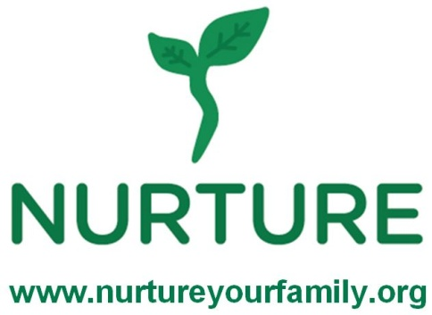
Family Program - Children
Program Evaluation Survey

To be completed by the Children’s coach during the last 5 minutes of each class.

Record number of children in class = ________
Which class was taught? ___ My Plate ___Go Slow ___ Beverages ___ Breakfast

Ask the children the following questions and record their answers.
- What was the most surprising thing you learned during class?

- Did you like today’s recipes? Would you want to make them at home?
Recipe 1:_____________________ Recipe 2: _____________________
Number of children who liked it = ____ Number of children who liked it = ____
Number who want to make it at home = ____ Number who want to make it at home = ____
Record any useful or positive comments.

- What was your favorite part of the class?

- (Skip this question during the first class)
Have you tried making any of the recipes at home?
Number of children who tried the recipes at home = ______
Which recipes have you made at home?

- (Ask this question only during last class.)
Since the start of these classes, have you made any changes to the foods you are eating?
Number children who made positive changes = _____
How have you changed the way you are eating?

- (Ask this question only during the last class.)
Since the start of these classes, have you changed your activity level?
Number of children who more physically = _____
How are you are being more physically active?

