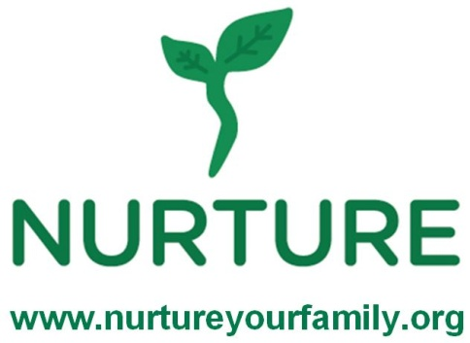
Family Program
Fruits & Vegetables and Portion Control

1. I will be able to feed my family healthier foods because of this class.
Strongly agree Agree Disagree Strongly disagree

2. I feel better prepared to exercise by myself or with my family because of this class.
Strongly agree Agree Disagree Strongly disagree

3. I would recommend this program to another family: Yes No

4. One way I learned for my family to eat more fruits and vegetables is:

5. One strategy I learned for how to control portions is:

6. My favorite part of the session was:

7. What was your opinion of the food prepared today?

Recipe I didn’t like it I loved it

_______________________________________________ 1 2 3 4 5
_______________________________________________ 1 2 3 4 5
_______________________________________________ 1 2 3 4 5
_______________________________________________ 1 2 3 4 5
Comments :

